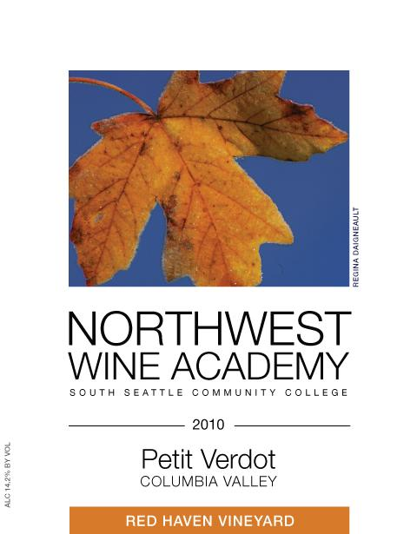
Factoids
French for Little Green, there are records of Petit Verdot as early as the late 16th and early 17th centuries. It is speculated that Petit Verdot descended from Balisca, which came from Albania from the Greeks and/or Romans.

2010 NWWA Petit Verdot

A delicious version of an Old World Classic: one of the grape varieties used in Bordeaux and surprisingly, proving to be very well suited to Washington climate. Not the inky black hard juice that might have been expected, Washington's wine country seems to have won over the grape with its long, warm growing season and winemaking talent- altogether a new way of looking at Petit Verdot
Dark, shiny, crimson red and superbly perfumed with a slightly herbaceous bouquet – anise & fennel, perhaps even tobacco and smoke! Lifted flavors of raspberry, cherry & spice are followed by succulent, rich berry fruit – mouthfilling and long lasting on the palate.

Food Pairings
A Petit Verdot, when in varietal or in a blend, is always a full-bodied wine, with higher tannins (especially in its youth), and is best paired with dishes that can stand up to that. Fantastic with steak or other red meats, particularly cooked rare. Bitter dishes, dishes with black pepper, duck, lamb, rich or salty foods are also fantastic for pairing with Petit Verdot. Avoid pairing with fish, creamy cheese dishes, or especially spicy foods.
Cases produced: 40
14.2% alcohol

Retail Price $25.00 Club Price $20.00

