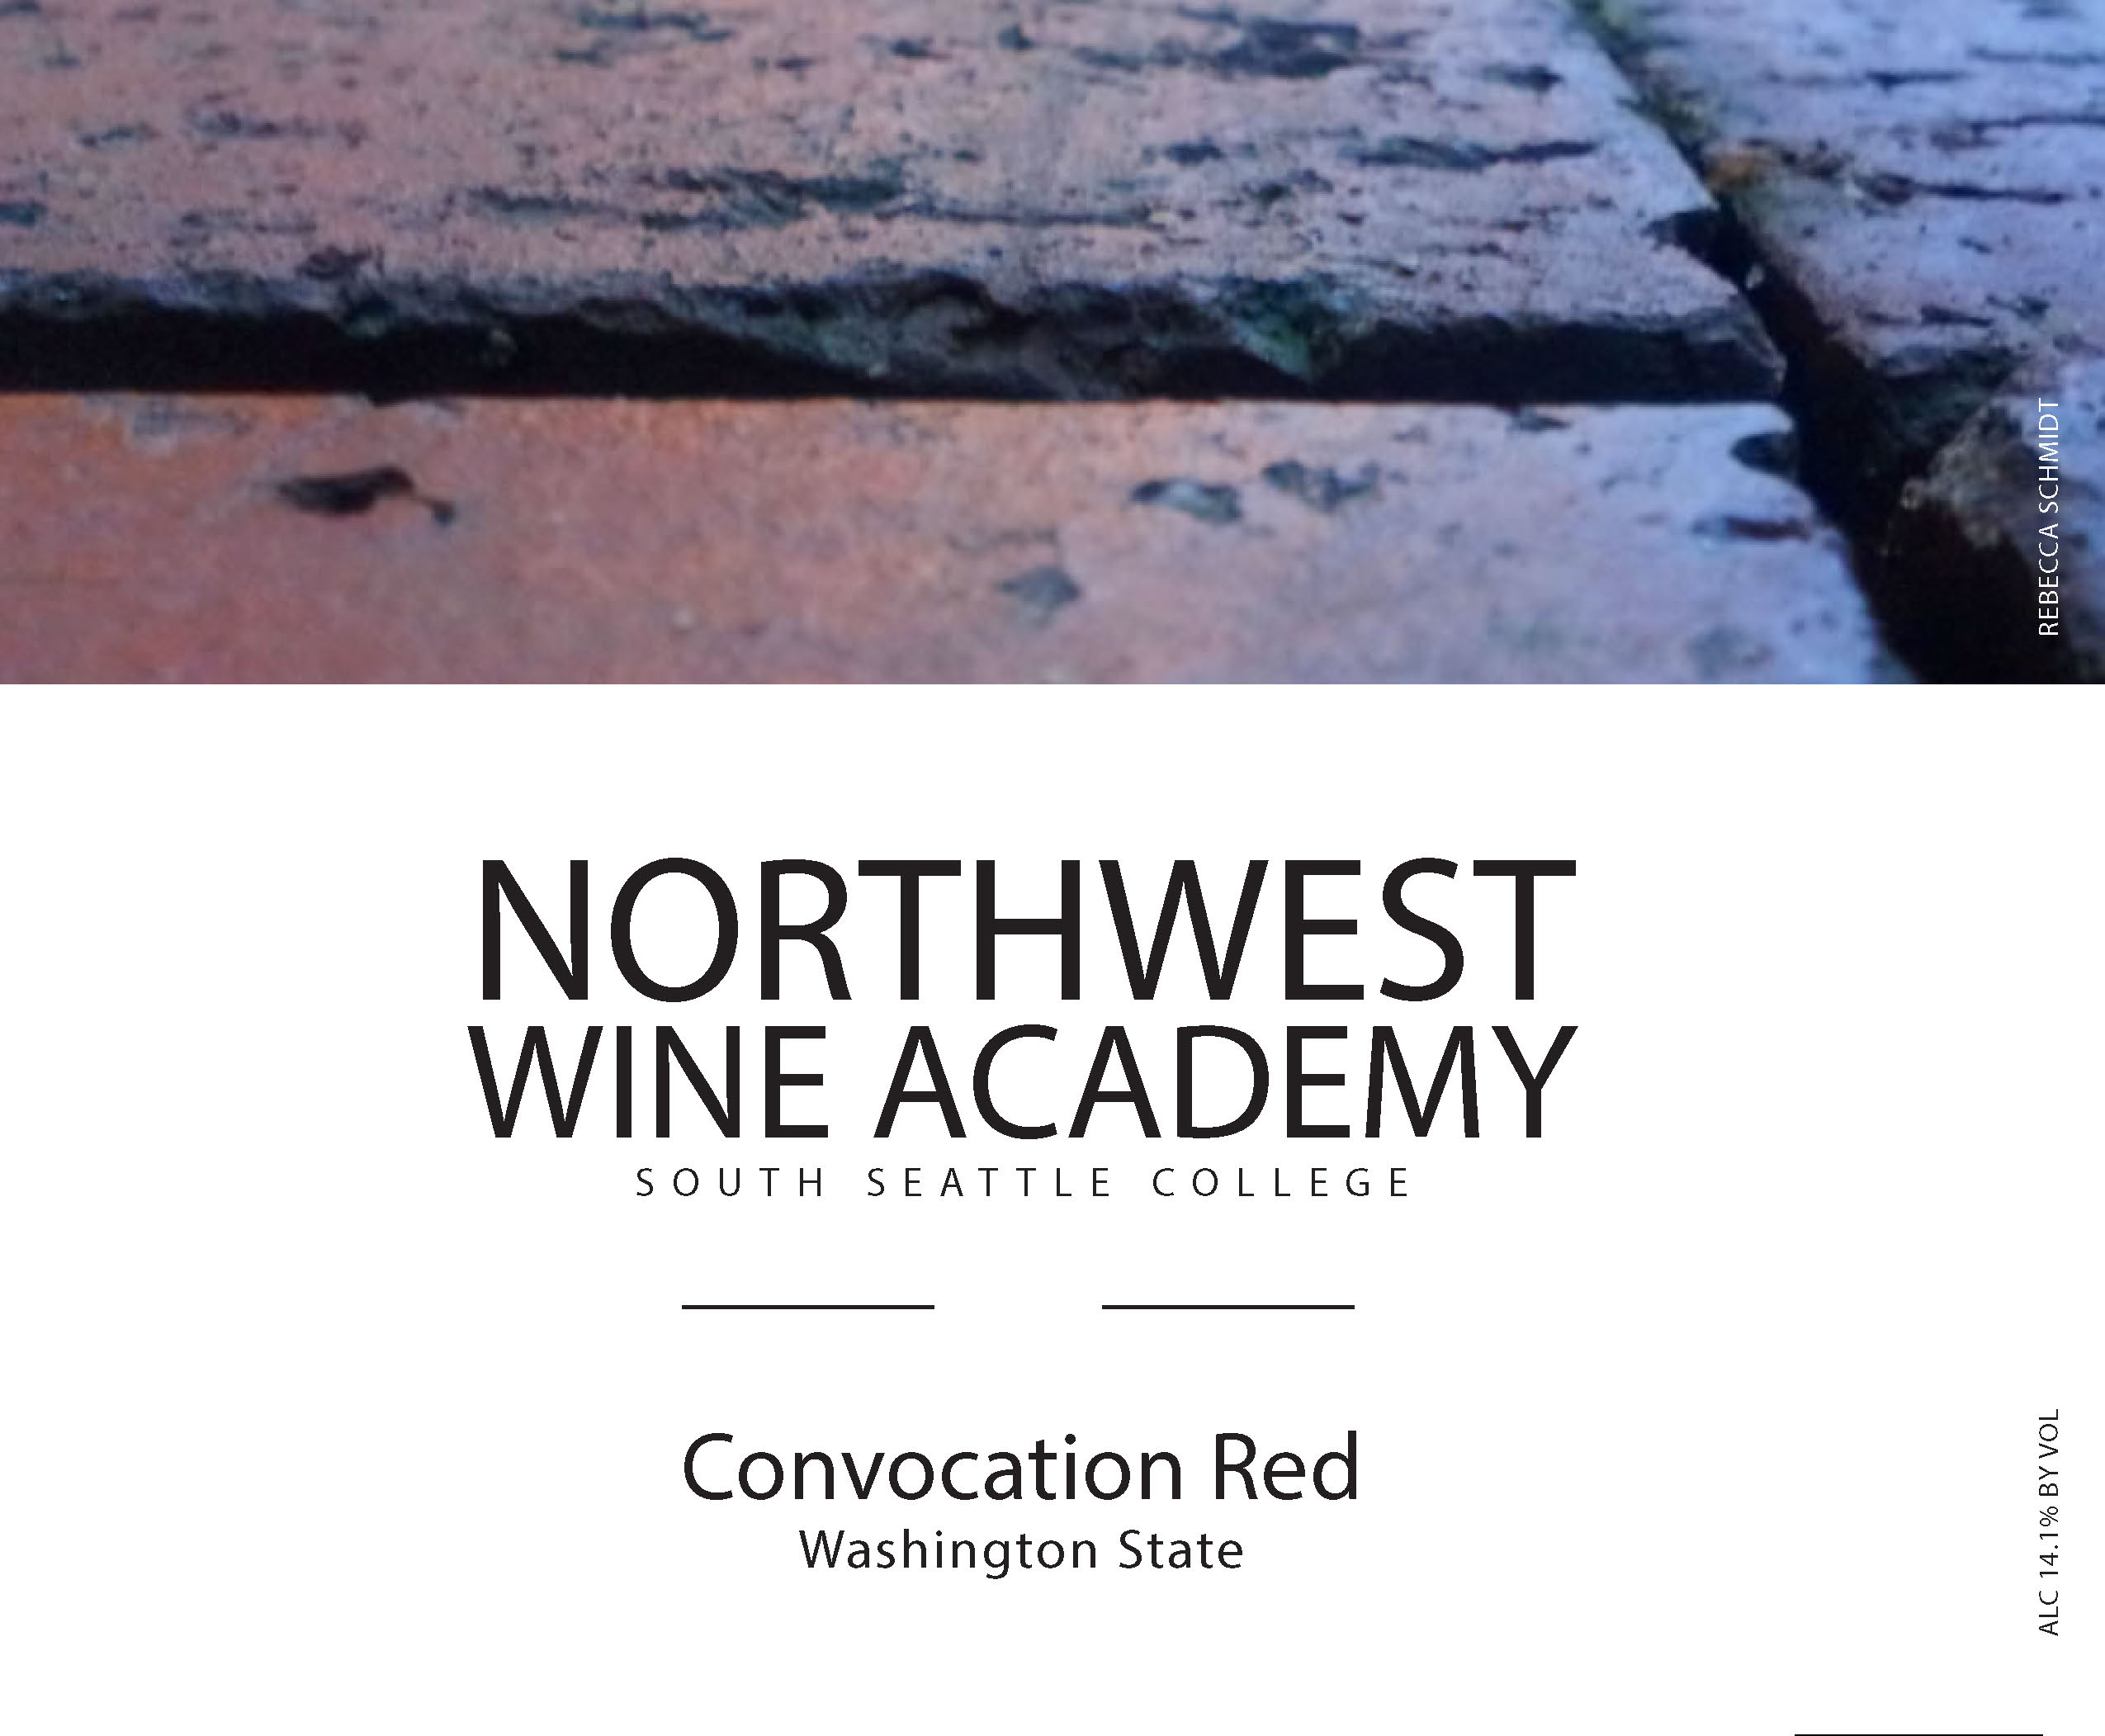

VINES

Carmenère

Merlot

Malbec

Petit Verdot

Cabernet Franc

CONVOCATION RED 2013
Washington State, USA

A convocation is a meeting of the members of a college or university to observe a particular ceremony, in this case the release of this wonderful red blend. Expressive with red fruit aromas and flavors of blackberry, figs, plums and raisins, balanced with appealing vanilla, sweet spices and some herbal notes.

ALCOHOL: 13.9% by volume
VARIETIES: 50% Carmenère, 20% Merlot,15% Malbec, 10% Petit Verdot and 3% Cabernet Franc.

PAIR: Grilled pork, mild blue cheese

Club Members get 20% off! It’s free to join. Ask how!

 | RETAIL | CLUB
BOTTLE: | $15 | $12
CASE: | $180 | $144

