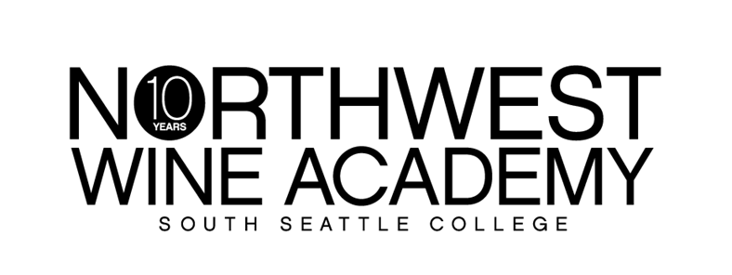
 | RETAIL | CLUB
BOTTLE | $18.75 | $15.00
CASE | $225.00 | $180.00
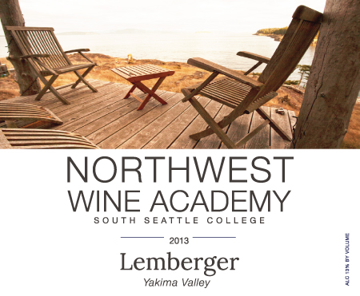
Planning a romantic picnic? You’ll want to add a bottle of our Lemberger to the basket.
This delicious red is amazingly smooth and buttery with juicy notes of cherry, strawberry and blueberry, as well as a hint of violet and oak.

Suggested pairings: works as well at the table as on a picnic, especially with game; think duck, venison, or lamb. It also complements simple fare like hamburgers or barbecue. Pastas are not out of the question, either; the acidity is there to cut rich, creamy sauces or balance with tomato sauces. Great with goat cheese, feta, or mushrooms too.
AVA: Yakima Valley
Alcohol: 13%
Cases produced: 112

Club benefits: 20% off retail price and an extra 10% off with 12 bottles or more!
It’s free to join. Ask how today!
6000 16th Avenue SW │ Seattle, WA 98106 │ (206) 934-7951 │ http://nwwineacademy.com
Lemberger 2013

