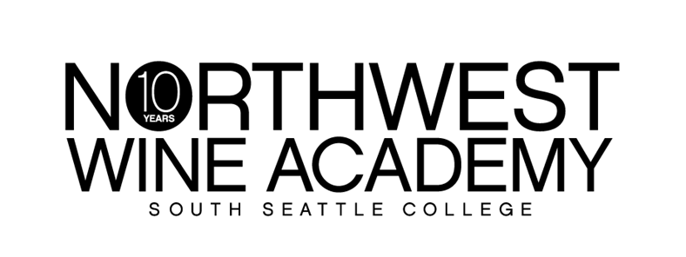

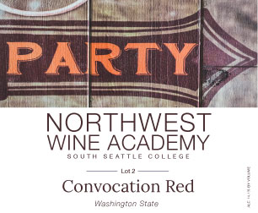

***Convocation Red Lot 2***

As spring days turn to long summer nights, it is the perfect time to get out the barbecue - and our Convocation Red is the perfect wine for your meal!

On the first taste, you’ll notice its bright and lifted acidity. Aromas of tobacco, cardamom and black cherry are followed by silky tannins on the palate with notes of smoked meats, cranberry, spicy plum, and raspberry.

**Suggested pairings:** Pizza, barbecued meats casseroles, grills and vegetables. **Lamb** with **herbs;** kebabs with mint and coriander; **medium bodied curry** or middle-eastern style meatballs. There’s a smoky edge that works well with dishes that include smoked bacon (think spinach, bacon and blue cheese salad); empanadas, especially with **green olives. The list is endless…….**

**AVA:** Washington State

**Alcohol:** 14.1%

**Cases produced:** 105

**Picked:** October 13-18, 2014

**Alcohol:** 13.5%

**Cases produced:** 105

|  |  |  |
| --- | --- | --- |
|  | **RETAIL** | **CLUB** |
| **BOTTLE** | **$18.75** | **$15.00** |
| **CASE** | **$225.00** | **$180.00** |

**Club benefits: 20% off retail price and an extra 10% off with 12 bottles or more!**

**It’s free to join. Ask how today!**

6000 16th Avenue SW │ Seattle, WA 98106 │ (206) 934-7951 │ http://nwwineacademy.com