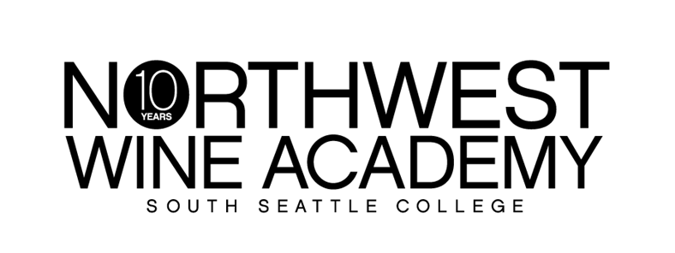

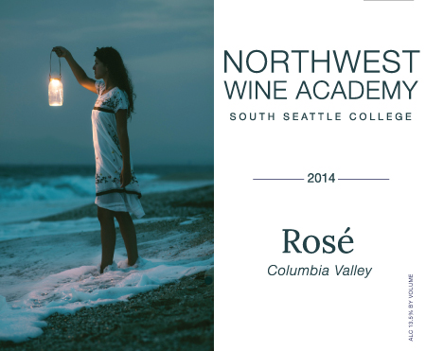

**AVA:** Columbia Valley

**Picked:** October 13-18, 2014

**Alcohol:** 13.5%

**Cases produced:** 105

Our crisp & dry Rosé is a blend of Pinot Gris and Zinfandel. Its beautiful orange-pink color is reminiscent of a spring sunset. Take a sip, close your eyes and you’re on white sand with the sun on your face!

Luscious notes of strawberry, pink grapefruit and a dash of fresh herbs.

**Suggested pairings:** A hugely versatile style that will stand up to big flavours such as anchovy, olives, garlic, saffron and pimento. Great wine to drink with tapenade, salade Niçoise, paella or grilled chicken, fish or lamb with herbs. (It’s also great for barbecues!)

|  |  |  |
| --- | --- | --- |
|  | **RETAIL** | **CLUB** |
| **BOTTLE** | **$18.75** | **$15.00** |
| **CASE** | **$225.00** | **$180.00** |

***Ros*é *2014***

**Club benefits: 20% off retail price and an extra 10% off with 12 bottles or more!**

**It’s free to join. Ask how today!**

6000 16th Avenue SW │ Seattle, WA 98106 │ (206) 934-7951 │ http://nwwineacademy.com