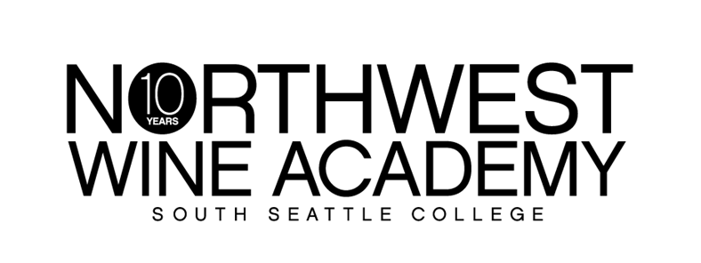
 | RETAIL | CLUB
BOTTLE | $18.75 | $15.00
CASE | $225.00 | $180.00
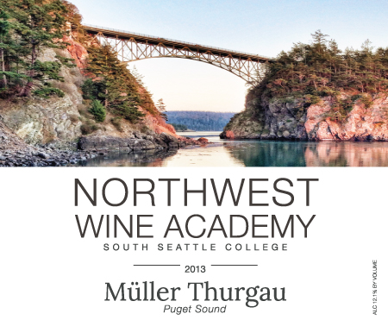
2014
With fresh and bright acidity, this brilliant, white-gold libation starts with a refreshing air of honeysuckle and finishes with a lively punch of green apple and a kiss of lime on your palate.

Suggested pairings: Prawns, smoked fish and crab remoulade, sharp cheeses, Waldorf salad and grilled vegetables. Poached or grilled salmon without a rich sauce. (Mayonnaise is fine. So is cucumber!)
AVA: Puget Sound
Picked: October 1, 2014
Alcohol: 12.1%
Cases produced: 75
Double Gold, 2015 Seattle Wine Awards
Silver Medal, 2015 Great Northwest Wine Awards

Club benefits: 20% off retail price and an extra 10% off with 12 bottles or more!
It’s free to join. Ask how today!
Müller-Thurgau 2014
(MEW-luhr TOOR-gow)

6000 16th Avenue SW │ Seattle, WA 98106 │ (206) 934-7951 │ http://nwwineacademy.com

